To mitigate unwanted shoreline erosion, a nourishment is being planned.

A choice must be made between a shoreface nourishment and a beach nourishment.

One of the involved engineers says that smaller volumes are required in case of shoreface nourishments.

*Is he right?*

|  |  |  |  |
| --- | --- | --- | --- |
|  | Yes |  | No |

A groyne system has been designed to protect a coastal stretch.

At the seaward edge of the active zone, the waves make an angle of 18° with the shore-normal of the original coastline.

Between the groynes the shoreline has reoriented itself with respect to the original coastline.

Locally, the coastline has rotated **over an angle of 6°**.

How large is the corresponding transport after construction of the groynes (SA) as a fraction of the original transport (So)*?*

*SA /So = [Preview](javascript:%20previewFormula('ans.1.0.0',%20'maple',%20'',%20''))  https://mapleta-bsprod1.tudelft.nl:8443/mapleta/client/mathEditor/images/ploton.gif*

Tip: You can write the final result (be sure to use at least 2 significant digits) or the mathematical expression in the equation editor (e.g. 1/5*3 is equivalent to 0.6 and both answers are accepted).

**Attention**: Use the point as a decimal separator, and be aware that the sin() and cos() functions take values in radians. For example, the cos of 5° must be written as cos(5*3.14/180). The arccosinus is written as arccos.

In the below figure, line *a* indicates the net yearly longshore sediment transport *S* along a straight coast with an alongshore varying wave climate.

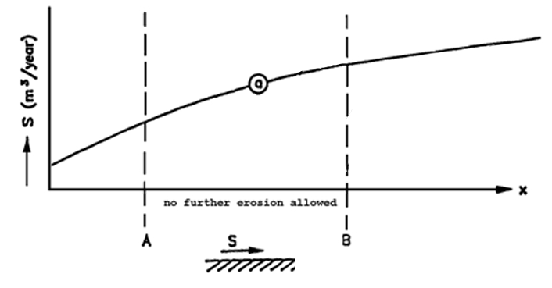

A groyne system was constructed to stabilize the coastline in section A-B.

Unfortunately the groyne system was designed incorrectly causing much stronger lee-side erosion than expected.

*After the engineering intervention, what is the relation between sediment transport at points A (SA) and B (SB)?*

|  |  |  |
| --- | --- | --- |
|  |  | SA is equal to SB |
|  |  | SA is lower than SB |
|  |  | SA is larger than SB |

*The below structures can effectively prevent or mitigate:*

 a) Nourishment

|  |  |  |
| --- | --- | --- |
|  |  | structural erosion |
|  |  | episodic erosion |
|  |  | both structural and episodic erosion |
|  |  | neither structural nor episodic erosion |

b) Sea dike

|  |  |  |
| --- | --- | --- |
|  |  | structural erosion |
|  |  | episodic erosion |
|  |  | both structural and episodic erosion |
|  |  | neither structural nor episodic erosion |

c) Revetment

|  |  |  |
| --- | --- | --- |
|  |  | structural erosion |
|  |  | episodic erosion |
|  |  | both structural and episodic erosion |
|  |  | neither structural nor episodic erosion |